Assignment 2
1
Import a dataset of your choice into Power Query. Implement a series of data transformations, including removing duplicates from a specified column, renaming at least three columns to more descriptive names, and applying a text filter to a column containing categorical data. Document each step in the 'Applied Steps' pane and provide a rationale for each transformation.

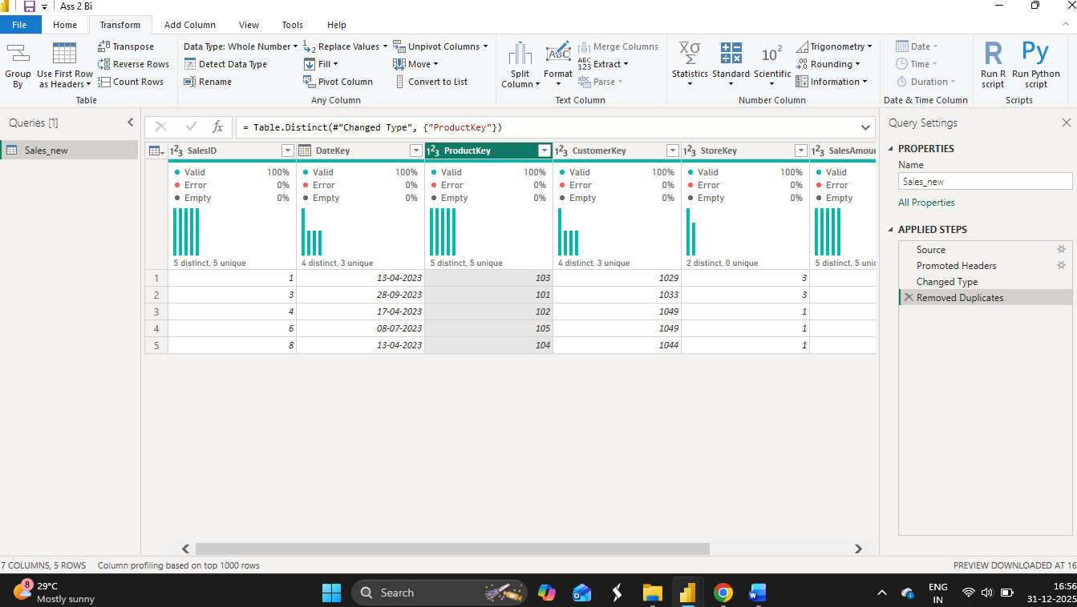

2
You have two datasets: one containing product information (ProductID, ProductName, Category) and another containing sales data (SaleID, ProductID, Quantity, Price). Design and implement a Power Query solution to merge these datasets using an appropriate join type to determine the total revenue generated by each product category. Explain your choice of join type and how it impacts the final result.

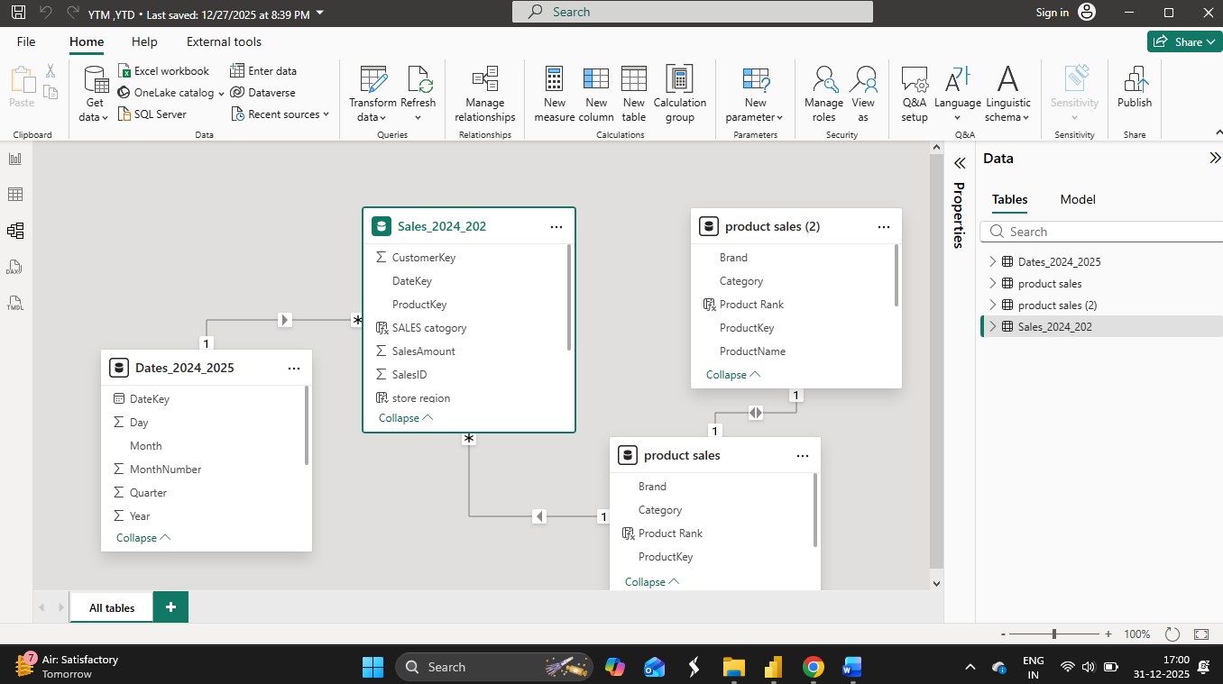

3
Consider a dataset with customer information, including a 'CustomerLifetimeValue' column. Create a conditional column named 'CustomerSegment' that categorizes customers into 'High Value', 'Medium Value', and 'Low Value' segments based on different thresholds for the 'CustomerLifetimeValue' column. Provide the M Query code generated for this conditional column and explain how you would modify it to add an additional segment.
= Table.AddColumn(
Source,
"CustomerSegment",
each
if [CustomerLifetimeValue] >= 100000 then "High Value"
else if [CustomerLifetimeValue] >= 50000 then "Medium Value"
else "Low Value",
type text
)
4
Using a dataset containing sales transactions (OrderID, CustomerID, OrderDate, ProductID, Quantity, Price), perform the following operations in Power Query: a) Group the data by 'OrderDate' to calculate the total sales for each day. b) Transpose the resulting table and then transpose it back. Analyze the impact of the transpose operations on the column names and data structure. c) Reverse the order of rows in the original sales transaction table and explain the potential use cases for this operation.
Power Query Operations on Sales Transaction Dataset
The given dataset contains the following columns: OrderID, CustomerID, OrderDate, ProductID, Quantity, and Price. The following operations were performed in Power Query.

a) Grouping Data by OrderDate to Calculate Total Sales
To calculate total sales for each day, a new column named Sales was created by multiplying Quantity and Price. The data was then grouped by OrderDate, and the total sales were calculated using the sum aggregation.
M Query Code:
let
Source = SalesData,
AddedSales = Table.AddColumn(Source, "Sales", each [Quantity] * [Price], type number),
GroupedData = Table.Group(
AddedSales,
{"OrderDate"},
{{"Total Sales", each List.Sum([Sales]), type number}}
)
in
GroupedData
This transformation results in one row per date with the total sales value for that day.

b) Transposing the Grouped Table and Transposing It Back
After grouping, the resulting table was transposed and then transposed back to its original form.
M Query Code:
let
TransposedOnce = Table.Transpose(GroupedData),
TransposedBack = Table.Transpose(TransposedOnce)
in
TransposedBack
Impact of Transpose Operation:
- When the table is transposed, column headers are converted into row values and rows become columns.
- Transposing the table again restores the original structure and column names.
- Performing transpose twice does not change the data but helps in understanding how Power Query reshapes data structures.

c) Reversing the Order of Rows in the Original Table
The rows in the original sales transaction table were reversed to change the order of records.
M Query Code:
= Table.ReverseRows(Source)
Use Cases of Reversing Rows:
- To display the most recent sales transactions first
- To prepare data for chronological or time-based analysis
- To align data order with external reports or systems

Conclusion
Power Query provides powerful transformation features such as grouping, transposing, and reversing rows. These operations help in summarizing sales data, restructuring tables, and improving data presentation for reporting and analysis.

5
You are given a dataset with website traffic data (Date, PageViews, UniqueVisitors, BounceRate). Your task is to use Power Query to perform the following: 1) Calculate the average 'PageViews' and 'UniqueVisitors' per month. 2) Create a new column that calculates the ratio of 'UniqueVisitors' to 'PageViews' for each day. 3) Filter the data to only include days where the 'BounceRate' is above a certain threshold (e.g., 0.5). Document the M Query generated for each step and explain how you could parameterize the BounceRate threshold for dynamic filtering.

Power Query Transformations on Website Traffic Dataset
The given dataset contains the following columns: Date, PageViews, UniqueVisitors, and BounceRate. The following transformations were performed in Power Query to analyze website traffic data.

1) Calculating Average PageViews and UniqueVisitors per Month
To calculate monthly averages, the Date column was first used to extract the Month and Year. The data was then grouped by Month and Year, and the average values of PageViews and UniqueVisitors were calculated.
M Query Code:
let
Source = WebTrafficData,
AddedYear = Table.AddColumn(Source, "Year", each Date.Year([Date]), Int64.Type),
AddedMonth = Table.AddColumn(AddedYear, "Month", each Date.Month([Date]), Int64.Type),
GroupedData = Table.Group(
AddedMonth,
{"Year", "Month"},
{
{"Avg PageViews", each List.Average([PageViews]), type number},
{"Avg UniqueVisitors", each List.Average([UniqueVisitors]), type number}
}
)
in
GroupedData
This step produces one record per month with average PageViews and UniqueVisitors.

2) Creating a Ratio Column (UniqueVisitors to PageViews)
A new column was added to calculate the ratio of UniqueVisitors to PageViews for each day. This ratio helps measure visitor engagement relative to page views.
M Query Code:
= Table.AddColumn(
Source,
"VisitorToPageViewRatio",
each [UniqueVisitors] / [PageViews],
type number
)
This column shows the proportion of unique visitors compared to total page views.

3) Filtering Data Based on BounceRate Threshold
The data was filtered to include only those records where the BounceRate is greater than 0.5.
M Query Code:
= Table.SelectRows(
Source,
each [BounceRate] > 0.5
)
This filter helps identify days with higher bounce rates, which may indicate user engagement issues.

4) Parameterizing the BounceRate Threshold
To make the BounceRate filter dynamic, a Power Query Parameter can be created.
Parameter Creation
- Parameter Name: BounceRateThreshold
- Data Type: Decimal Number
- Current Value: 0.5
Modified M Query Using Parameter
= Table.SelectRows(
Source,
each [BounceRate] > BounceRateThreshold
)
Explanation
By using a parameter, the BounceRate threshold can be changed without modifying the query logic. This allows dynamic filtering and makes the report more flexible for different analytical requirements.

Conclusion
Using Power Query, monthly averages were calculated, a daily engagement ratio was created, and high bounce rate days were filtered. Parameterizing the BounceRate threshold improves reusability and enables dynamic data analysis.

6
Design a Power Query solution to address a common data quality issue: inconsistent date formats. You have a dataset with a 'Date' column that contains dates in various formats (e.g., 'MM/DD/YYYY', 'YYYY-MM-DD', 'DD-MMM-YY'). Implement a series of transformations in Power Query to standardize the 'Date' column into a single, consistent format ('YYYY-MM-DD'). Explain the challenges involved in handling different date formats and how your solution addresses them.

1) Calculating Average PageViews and UniqueVisitors per Month
To calculate monthly averages, the Date column was used to extract the Year and Month. The data was then grouped by Year and Month, and the average values of PageViews and UniqueVisitors were calculated.
M Query Code:
let
Source = WebTrafficData,
AddedYear = Table.AddColumn(Source, "Year", each Date.Year([Date]), Int64.Type),
AddedMonth = Table.AddColumn(AddedYear, "Month", each Date.Month([Date]), Int64.Type),
GroupedData = Table.Group(
AddedMonth,
{"Year", "Month"},
{
{"Avg PageViews", each List.Average([PageViews]), type number},
{"Avg UniqueVisitors", each List.Average([UniqueVisitors]), type number}
}
)
in
GroupedData
This transformation produces one record per month showing the average PageViews and UniqueVisitors.

2) Creating a Ratio Column (UniqueVisitors to PageViews)
A new column was created to calculate the ratio of UniqueVisitors to PageViews for each day. This ratio helps in measuring user engagement relative to total page views.
M Query Code:
= Table.AddColumn(
Source,
"VisitorToPageViewRatio",
each [UniqueVisitors] / [PageViews],
type number
)
This column represents the proportion of unique visitors compared to total page views.

3) Filtering Data Based on BounceRate Threshold
The dataset was filtered to include only those records where the BounceRate is greater than 0.5.
M Query Code:
= Table.SelectRows(
Source,
each [BounceRate] > 0.5
)
This filter helps identify days with high bounce rates, which may indicate potential issues with user engagement.

4) Parameterizing the BounceRate Threshold
To make the BounceRate filtering dynamic, a Power Query Parameter was created.
Parameter Details:
- Parameter Name: BounceRateThreshold
- Data Type: Decimal Number
- Current Value: 0.5
Modified M Query Using Parameter:
= Table.SelectRows(
Source,
each [BounceRate] > BounceRateThreshold
)
Explanation:
Using a parameter allows the BounceRate threshold to be changed without modifying the query code. This improves flexibility and reusability of the report for different analysis requirements.

Conclusion
Using Power Query, monthly average metrics were calculated, a daily engagement ratio was created, and high bounce rate days were filtered. Parameterizing the BounceRate threshold enables dynamic filtering and enhances analytical flexibility.

